First Grade STEM Ideas – Week 2
Parts of a Plant  Click here to see a video from Mrs. Wilfred! | - Watch this Video  www.generationgenius.com/?share=B854F  - Draw a plant on a piece of paper and label all the parts.  - Find a plant inside or outside and name the parts.  Extension: Eat the parts of a plant!  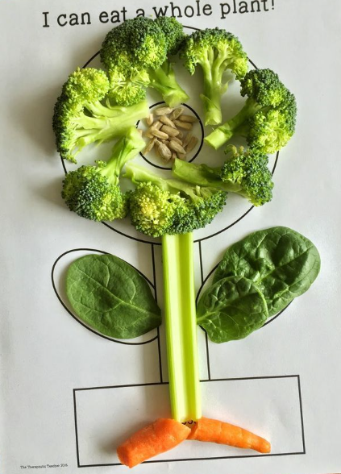

Unplugged Activities
Choose One and Have Fun!
Read a book: What was the problem in the story? Build something to help solve the problem. | Create a kite: Use materials that you have at home to design a kite. Does your kite fly? | Make a tower: Build a tower out of cups or cans. How tall is your tower?
Design a marble run: Use paper plates, toilet paper rolls, scissors, and tape to design a marble run (maze). | Scavenger Hunt: How many things can you find that starts with the same letter as your first name? If you can, do this outside! | Design a pair of glasses: Use materials that you have at home to design a stylish pair of glasses.

