First Grade STEM Ideas – Week 3
Plants  Click here to see a video from Mrs. Wilfred | - Watch https://www.youtube.com/watch?v=ql6OL7_qFgU  - Tell someone the parts of a plant and the job of each part.  - Grab things around your home to create a plant that shows the plant’s roots, stem, leaves, and flowers. I would love for you to post your creation on Seesaw!  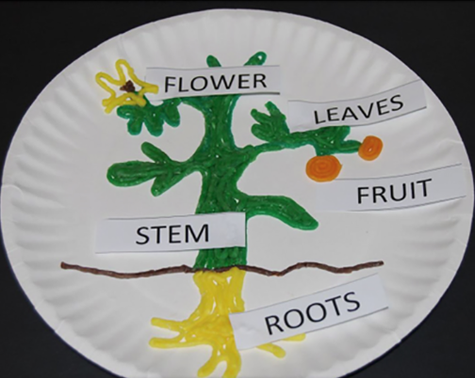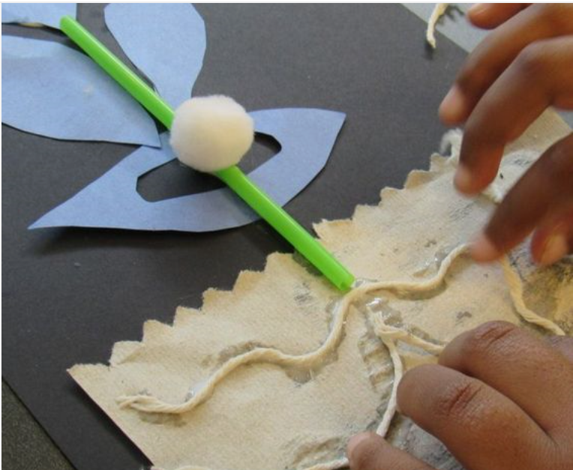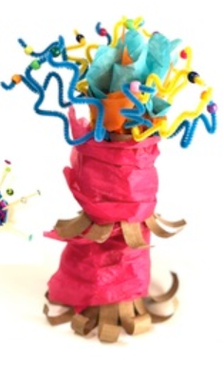

Unplugged Activities
Choose One and Have Fun!
Learn to Sew: Ask a grown-up to help you thread a needle. Find something to practice sewing! | Experiment: Sprinkle pepper into a dish of water. Dip one finger into dish soap then touch the surface of the water. What happens? | Nature: Create a pattern using items from nature.
Invent: Design and create something to solve a problem in your home. | Musical Cups: Put different amounts of water in glass containers. Tap gently to make music! | Architect: Make a blueprint of your house. Label all your rooms. (Or make a blueprint of your dream house!)

