Kindergarten STEM Ideas – Week 3
Garden  Click here to see a video from Mrs. Wilfred | - Watch https://www.youtube.com/watch?v=cRhGOdqWIIo  - Build a garden. It can be a flower garden, vegetable garden, a mixed garden, anything! You can build it out of Legos, Play-doh, craft materials, paper, whatever you can find.  - Do any of your plants have similar features?  - I would love to see your garden! Post a picture of video on Seesaw or email it to me. Pamela.wilfred@cobbk12.org  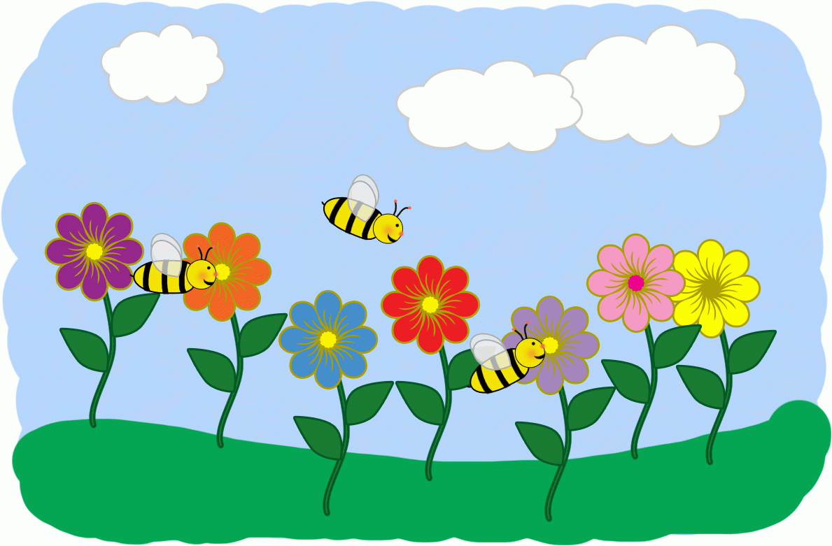

Unplugged Activities
Choose One and Have Fun!
Learn to Sew: Ask a grown-up to help you thread a needle. Find something to practice sewing! | Experiment: Sprinkle pepper into a dish of water. Dip one finger into dish soap then touch the surface of the water. What happens? | Nature: Create a pattern using items from nature.
Invent: Design and create something to solve a problem in your home. | Musical Cups: Put different amounts of water in glass containers. Tap gently to make music! | Architect: Make a blueprint of your house. Label all your rooms. (Or make a blueprint of your dream house!)

