Second Grade STEM Ideas – Week 3
Volcano  Click here to see a video from Mrs. Wilfred | - Complete the following Mystery Science lesson: https://mysteryscience.com/mini-lessons/mountain-volcano?code=f0be69d962864cae26bb4683d303a148#slide-id-7051  - Draw a picture of how a volcano can change the environment. Take a picture of your drawing and upload it to Seesaw (or email it to me).  Extension: Create a volcano! Baking soda and vinegar will cause an eruption.  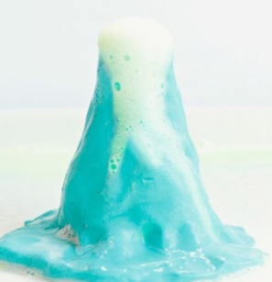

Unplugged Activities
Choose One and Have Fun!
Learn to Sew: Ask a grown-up to help you thread a needle. Find something to practice sewing! | Experiment: Sprinkle pepper into a dish of water. Dip one finger into dish soap then touch the surface of the water. What happens? | Nature: Create a pattern using items from nature.
Invent: Design and create something to solve a problem in your home. | Musical Cups: Put different amounts of water in glass containers. Tap gently to make music! | Architect: Make a blueprint of your house. Label all your rooms. (Or make a blueprint of your dream house!)

